Understanding the Causes, Impact, and Interventions for Gun Violence: A Qualitative Analysis of Community Perceptions and Social Influences

Author name

Institutional affiliation

Course number and name

Instructor name

Assignment due date

This section presents findings from the analysis of 52 transcripts using NVivo to generate nodes and themes based on the key aspects of gun violence. The study examines the accessibility and sources of firearms, causes of gun violence, community perceptions, the impact of gun violence, the role of media and entertainment, and possible solutions and interventions. The themes and subcategories were derived from participant responses and categorized based on recurring patterns in their narratives.

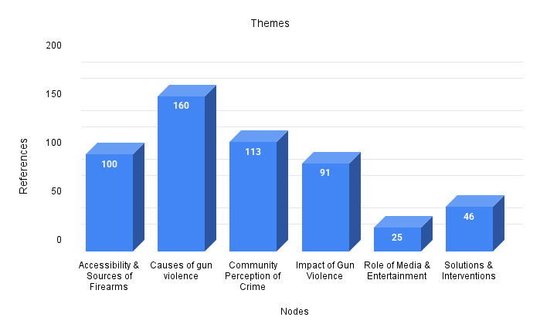

Figure 1 Themes

**1. Causes of Gun Violence**

The factors or incidences that exhibit gun violence act, such as retaliation or gang violence, received the highest mentions in the dataset. It recorded a staggering 160 mentions. Out of these, only 10 respondents emphasized the consequences of gun violence and the enactments which lead up to it. This proves that participants largely discussed the reasons for gun violence rather than just giving its overview.

A number of reasons are given above and in detail as follows:

*Gang activity and retaliation*: Notably, a significant proportion of respondents highlighted the fact that violence such as disputes ending in fist fights or physical altercations being transformed in shooting is escalated by the presence of gangs.

*Social media arguments and fights*: Many people abandon the realm of the virtual world and pick up actual physical violence which is inherently enacted in self-defense.

*Personal protection*: Even though young people are not involved in crime, the presence of lack of security and fear leads them to carry weapons for self-defense while roaming in public spaces.

*Peer Pressure*: Guns are carried a lot by the youth because of the influence that older people or people in their social circles exert upon them.

**2. Community Perception of Crime**

This node reflects how respondents view crime in the society and received 113 references. It emerged that a rather broader category of respondents feel that crime is omnipresent and to a large extent, accepted as normal.

Key observations:

* Individual who feel and express numbness to crime regard gun violence as a social norm surrounded by a blind eye.
* Rest, while holding him to even minor standards, highlight crime pertaining to violence and insecurity arising out of lack of trust on/against law enforcement.
* References made suggest that crime solving effectiveness and elimination policing do not seem to be very popular within the participants of the study which points towards some criticism in focus.

This aspect is necessary as it focuses on how perceptions regarding crime alter conduct. Those who are convinced that there is no escape from violent resolution tend to restrain themselves from the less violent resolution, making crime and retaliation self-perpetuating.

**3. Accessibility & Sources of Firearms**

As noted in the dataset, the deep rooted issue of firearams procurement is unduly alarming, generating debate in 100 different seminars. Firearms are purchased on the black market, through social connections, or acquisition of guns by theft. A few respondents claim that guns are sold for a fraction of the reasonable price in specific regions where there are lenient laws. Proliferation of firearms through family members, older associates, or the more familiar underground network has become the order of the day.

The lack of barriers regarding firearm ownership serves as a crucial contributor towards violence. A majority of the users stated a possibly disturbing fact that firearms are easily obtainable to untrained youths for shooting. A new aspect of firearm abuse becomes visible and is best understood as aggressive acts being committed after the escalation of a dispute.

**4. Impact of Gun Violence**

With 91 references this theme looks into the impacts of gun violence at the individual, family, and community levels.

Key findings:

* Many particpants had experienced the loss of family and friends through gun violence.
* There is a major psychological impact that loses inflicts on the trauma stricken family which brings restlessness, anxiety, and PTSD.
* Some people feel a profound sense of misanthropy and previously described violence that people have long faced, feeling to believe that gun violence will never be curtailed.

Apart from all involved directly or indirectly, gun violence affects children who are forced to bear witness leading to emotional and psychological trauma of dire consequences. They are most vulnerable to such scenarios when justice appears to be elusive due lack of action by police.

**5. Solutions & Interventions**

With 46 references, this theme had the lower compared to the causes and impact of gun violence. This lower count suggests that respondents spent more time elaborating the issues rather than approaches.

But perhaps the most common solution volunteered by participants include:

* Adoption of Ontario style gun regulations - Some respondents suggest that curtailing the availability of firearms will lead to lower violence levels.
* Community based programs - a sizable number believe that outreach, mentoring, and employment programs can help in avoiding violence among youth.
* Legal reforms along with stronger enforcement - Although law enforcement is highly criticized within this society, some argue that advanced policing approaches could increase safety overall.

There is an element of frustration and resignation that is reflected in the relatively low reference count for this solution. Many participants do not seem to notice immediate or effective efforts to address gun violence.

**6. Role of Media & Entertainment**

This section has the lowest count of references (25), suggesting that the role of media, although forthcoming, does not seem to be the greatest concern for all participants.

The youth are often glamorized towards gun violence from music and social media, and thus become habitual. A section of participants believe that media is harmful as it overexposes issues and negative stigma towards the people in these communities, causing more division instead of sympathy. Nevertheless, a majority of people think violence is mainly caused by social issues, not media.

Participants have recognized that such direct social influences (peer pressure, gangs, accessibility of guns) are more notable reasons for the gun violence and warrant the lower count for the media’s influence as a reason for violence.

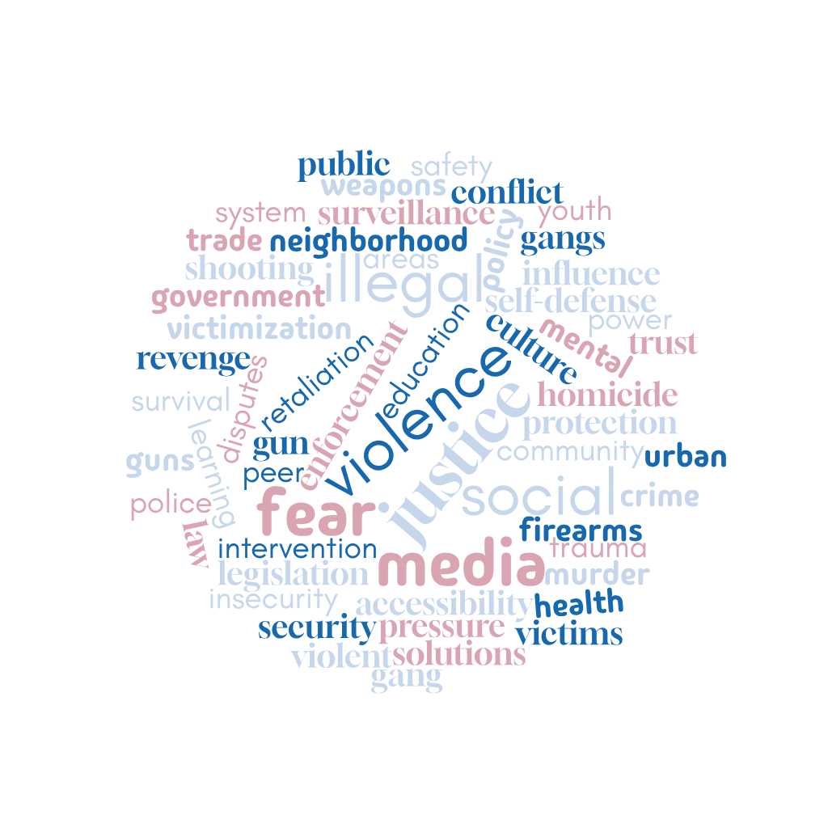

Figure 2 Word cloud

|  |  |  |
| --- | --- | --- |
| Themes | Sub category/node | Quote |
| Accessibility & Sources of Firearms | Ease of Obtaining Guns, | “These days, people can get a gun off the street. It's so easy. You don't even know. See a little kid walking around with a gun” *Cam Cincinnati Participant 1* |
|  | Knowledge on Firearm Use (Self-Taught, Family, Online Resources), | “They use them when they get out of there. They probably take it somewhere, test it out on somebody or take it somewhere. Like in the woods, probably. But nowadays, every kid know how to use a gun or even know where to find one.” J Young participant 1 |
|  | Sources of Illegal Firearms (Government, Private Dealers, | “I think they coming from these gangs, taking them from their parents and people just giving them guns.” ” *Cam Cincinnati Participant 1* |
| Causes of gun violence | Crime & Gang Activity, Perceived Need for Self-Protection | “I feel like some people would just care for the protection. Chicago’s a wild place.” F Cannon Participant 1 |
|  | Influence of Social Media and Online Feuds | “I think social media play a big role because nowadays everything is based around it so its like you can start beefing with someone over the net and they catch you lacking in person. You talking bout yeah ill shoot you over the phone but whole time they next day they catch you and shoot you. People” *Cam Cincinnati Participant 1* |
|  | Peer Influence | “Yeah, most people get peer pressure to do stuff like that. And gets sent off to go shoot somebody because the person who sent them off ain't going to go do it because it's dumb. So, they just send a kid off, who want to be tough to go shoot somebody or kill somebody.” F Cannon Participant 1 |
|  | Crime and gun culture | “They always dissing and want to kill this person kill that person. And they think the quickest way to kill people is by using a firearm and stuff like that. And they always talking about the death of somebody loved ones” F Cannon Participant 6 |
| Community Perception of Crime | General Crime Trends | ”A lot of crime, no, not for real. Like, do I see a lot of crime? Yeah, it's a lot of, yeah, a lot of people see crimes. Yeah, like, you know, that's regular stuff though” J Davis Participant 2 |
|  | Law Enforcement Response | “Probably like, they need to start patrolling (the police), or community service (outreach just stuff to keep these guns off the street, put the goods down.” *Cam Cincinnati Participant 1* |
| Impact of Gun Violence | Emotional & Psychological Effects, | “It hurts, it just hurt, from the day they passed away to now it hurts. Especially when someone brings it up|” *Cam Cincinnati Participant 1* |
|  | Fear & Insecurity in the Community | “It makes mee feel like this is what my environment has come to. I feel like our future won’t be nothing because of all this violence. I just be thinking, what had too happened for things to come down to that and make people do those type of things” F Cannon Participant 5 |
|  | Loss of Family & Friends | “Yeah, I lost my daddy to gun violence, my uncle, and my cousins, and my big brother.” F Cannon Participant 4 |
| Role of Media & Entertainment | Glorification of Guns in Pop Culture | “yeah, basically media glorifies gun violence because you see it everywhere” *Marcus Participant 4* |
|  | Influence of Violent Media on Youth | “The music is influencing gun violence through the words and the image people putting on for these kids. the environment they're giving guns and killing people saying they did this and that to people” *Cam Cincinnati Participant 1* |
| Solutions & Interventions | Law enforcement strategies | “Probably like, they need to start patrolling (the police), or community service (outreach just stuff to keep these guns off the street, put the goods down.” *Cam Cincinnati Participant 1* |
|  | Community based programs | “I would say that we all just need to come together, and people just need to stop killing cause they be killing each other for goofy stuff.” *Cam Cincinnati Participant 1* |
|  | Policy and legislative measures | “I think guns should be banned because kids dying along with innocence, I think the only people that should have guns is the police and they should have less lethal weapons” .” F Cannon Participant 4 |

**Discussion**

**Sources of Firearm Firearms Accessibility & Sources of Firearms are Extensive and Widespread**

**This study suggests that young people have access to firearms ranging from private dealers and family members to gangs. Participants often shared the little regulation firearm possession is subjected to within their localities.**

**“Nowadays, anyone can easily walk into the streets and fetch a gun. It’s effortless. There is a child walking around with a gun." - Cam Cincinnati, Participant 1, 2021**

**The evidence supports Cohen and Felson's 1979 Routine Activity Theory, which states that crime occurs when a motivated offender, capable guardian, and a target coincide (**Cohen, & Felson, 2010)**. The availability of firearms combined with ineffective law enforcement increases the probability of gun violence. Crimes such as acquiring a firearm are a result of the Strain Theory proposed by Merton(1957). Those who do not possess legitimate means to achieve economic and social progression will acquire them by any means necessary. In particular, younger populations in high crime areas are conditioned to view firearms as essential items for protection making a weapon violence cycle.**

**Causes of Gun Violence**

*Crime & Gang Activity, Perceived Need for Self-Protection*

Participants frequently mentioned self-assistance and gang violence as major reasons for gun possession:

"'I think some people would be bothered just for the protection, oh has to Chicago's wild place.'" -F Cannon, Participant 1

This is consistent with Social Learning Theory (Bandura, 1977), where a person learns and adopts behaviors through observation and consequences. The youth are socialized into a gun culture in violent subcultures as a part of life.

*Influence of Social Media and Online Feuds*

Social media plays a notable part in the increase of violence because virtual conflicts can easily turn into physical fights:

"'I think social media has a significant contribution because everything is based around,” so you can start beef with somebody over the net and they run into you when you are lacking in the streets.'" — Cam Cincinnati, Participant 1.

*Influence of Peers*

Peer violence is often indicated as a cause of firearm related violence, particularly for the young and adolescent children.

“Yeah, most people get peer pressure to do stuff like that. And gets sent off to go shoot somebody because the person who sent them off ain’t going to do it because it’s dumb.” – F Cannon, Participant 1

This explanation matches Sutherland’s Differential Association Theory of 1947 which maintains that an individual’s behavioral deviance is determined by the close personal interaction of the individual. Young people with access to and exposure to guns are more susceptible to accepting norms of violence (Matsueda, 2001).

**Community Perception of Violence**

**In terms of law enforcement, participants held mixed views with some favoring more aggressive policing and others being skeptical of the police.**

**“Probably like, they need to start patrolling (the police), or community service (outreach just stuff to keep these guns off the street, put the guns down.” – Cam Cincinnati, Participant 1**

**The Broken Window hypothesis assumes that firearms and other weapons signified to violence abuse will emerge and highly crime infested areas if more crimes are not governed (**Van der Weele et al., 2017)**. The lack of policing inflexibility may increase the boldness of criminals and thus, lower the general community confidence in law enforcement. Notably, some participants were not convinced of the helpfulness of police involvement considering the issues of racial profiling and use of excessive force and authority.**

**Consequences of Gun Violence**

**The consequences of gun violence are felt at the emotional, psychological, and social levels all at once.**

***Emotional and Psychological Effects***

**“Every day I remember it; it hurts so much. I’m in pain especially when the topics comes up.” – Cam Cincinnati, Participant 1.**

**Families and community members of victims have to bear chronic psychological trauma which is in line with Duwe’s research (2017), which states, “Gun violence is a leading cause of PTSD symptoms, anxiety, and extreme aggressiveness among survivors.”**

***Community Fear and Insecurity***

**“Because of the violent acts in our community, I feel like this is what my environment has come to. There isn’t any hope for a brighter future.” – F Cannon, Participant 5**

**This elucidates the notion of Collective Efficacy, which states that areas inhabited by people with low social trust and high fear are known to have higher incidence rates of crime), but there is no social action that can hinder its rate.**

***Loss of Family and Friends***

**“Yes, my uncle, cousins, my big brother and most importantly I lost my daddy due to gun violence.” – F Cannon, Participant 4**

**This pattern of violence has been articulated in the field of criminology, reinforcing the idea more systemic interventions are needed.**

**Effects of Media and Entertainment**

***The Use of Guns in Popular Culture***

**“Yeah, almost media glorifies it the same way you see gun violence in a music video.” - Marcus, Participant 4**

**This corresponds with Cultivation Theory which states that a consistent pattern of violence in media results in acceptance of aggression and crime as a normal way of life (**Shrum, 2017)**.**

***Youth Exposure to Violent Media***

**“The music is influencing gun violence through the words and the image people are trying to put out for these kids.” – Cam Cincinnati, Participant 1**

**This supporting finding is correlational and rests on Anderson et al., (2003) research which claims that violence in music can be aggressive stimulus in the minds of young listeners.**

**Recommendations & Strategies**

***Maintaining Order Intervention***

**“Probably like, they need to start patrolling, or community service outreach, just stuff to like keeping these guns off the street, put the guns down.” – Cam Cincinnati, Participant 1**

***Community Implemented Initiatives***

**“I would say that we all just need to come together, cause people need to stop killing because they be killing each other for goofy stuff.” – Cam Cincinnati, Participant 1**

**This is consistent with Community Policing Strategies** Lowry (2021) **which stress the need for joint activities between law enforcement agencies and the community.**

***Policy and Legislative Measures***

**"My opinion is that guns should be irrelevant as there should not be children dying alongside innocence." - F Cannon, Participant 4**

Implementing background checks and restrictions on the sale of firearms, for instance, have helped lower death rates caused by gun use in Australia and the UK (Greenberg et al., 2024).

**Conclusion**

**It has been established that gun violence is a complex issue that stems from social, economic, and cultural problems. Social Learning, Routine Activity, and General Strain Theory explain the reasoning behind committing acts of violence with a gun. However, possible solutions have to be in the form of community action, police reform, and policy making. Controlling gun violence requires an approach that enables the dismantling of the trauma and crime cycle existing in the community.**

References

Anderson, C. A., Berkowitz, L., Donnerstein, E., Huesmann, L. R., Johnson, J. D., Linz, D., ... & Wartella, E. (2003). The influence of media violence on youth. *Psychological science in the public interest*, *4*(3), 81-110.

Bandura, A. (1977). Social learning theory. *Englewood Cliffs*.

Cohen, L. E., & Felson, M. (2010). Social change and crime rate trends: A routine activity approach (1979). In *Classics in environmental criminology* (pp. 203-232). Routledge.

Duwe, G. (2017). Effectiveness of prison-based education programming and the implications for correctional policy and practice. *Criminology & Pub. Pol'y*, *16*, 511.

Greenberg, B., Bennett, A., Naveed, A., Petrut, R., Wang, S. M., Vyas, N., ... & Ahmed, N. (2024). How firearm legislation impacts firearm mortality internationally: A scoping review. *Health Policy OPEN*, 100127.

Lowry, C. (2021). *How Law Enforcement Professionals Bridge the Gap between Themselves and Communities They Serve during Times of Crisis* (Doctoral dissertation, Point Park University).

Matsueda, R. L. (2001). Differential association theory. *Encyclopedia of criminology and deviant behavior*, *1*, 125-130.

Merton, K. R. (1957). Strain theory. *Readings in deviant behavior. New York: HarperCollins College Publishers*.

Shrum, L. J. (2017). Cultivation theory: Effects and underlying processes. *The international encyclopedia of media effects*, *1*, 1-12.

Van der Weele, J. J., Flynn, M. P., & Van der Wolk, R. J. (2017). Broken window effect. *Encyclopedia of Law and Economics New York: Springer*.

**APPENDICES**

**APPENDIX 1: Word Frequency**

|  |  |
| --- | --- |
| Word | Weighted Percentage (%) |
| like | 4.79 |
| people | 3.28 |
| think | 2.42 |
| gun | 2.09 |
| just | 2.00 |
| community | 1.93 |
| yeah | 1.73 |
| know | 1.54 |
| feel | 1.47 |
| lot | 1.38 |
| get | 1.36 |
| guns | 1.34 |
| violence | 1.29 |
| really | 1.16 |
| stuff | 1.12 |
| got | 1.08 |
| see | 1.08 |
| make | 0.81 |
| going | 0.68 |
| carry | 0.65 |
| young | 0.65 |
| crime | 0.56 |
| aint | 0.55 |
| police | 0.54 |
| use | 0.54 |
| family | 0.51 |
| media | 0.49 |
| want | 0.49 |
| need | 0.45 |
| friend | 0.45 |
| ain't | 0.44 |
| take | 0.44 |
| everybody | 0.43 |
| learn | 0.42 |
| one | 0.41 |
| chicago | 0.41 |
| time | 0.41 |
| describe | 0.40 |
| somebody | 0.40 |
| easy | 0.39 |
| cause | 0.38 |
| mean | 0.38 |
| member | 0.37 |
| gangs | 0.36 |
| life | 0.36 |
| something | 0.36 |
| even | 0.36 |
| kids | 0.36 |
| role | 0.36 |
| live | 0.35 |
| solve | 0.35 |
| around | 0.32 |
| now | 0.31 |
| real | 0.31 |
| getting | 0.30 |
| right | 0.30 |
| gone | 0.28 |
| job | 0.28 |
| friends | 0.27 |
| lost | 0.27 |
| ever | 0.27 |
| whole | 0.27 |
| back | 0.26 |
| close | 0.26 |
| homeless | 0.26 |
| interview | 0.26 |
| nothing | 0.25 |
| trying | 0.25 |
| happening | 0.24 |
| buildings | 0.23 |
| much | 0.23 |
| old | 0.23 |
| probably | 0.23 |
| way | 0.23 |
| lived | 0.22 |
| look | 0.22 |
| neighborhood | 0.22 |
| person | 0.22 |
| yes | 0.22 |
| abandoned | 0.22 |
| basically | 0.22 |
| gang | 0.21 |
| murders | 0.21 |
| influenced | 0.21 |
| come | 0.20 |
| coming | 0.20 |
| drives | 0.20 |
| play | 0.20 |
| type | 0.20 |
| black | 0.19 |
| lie | 0.19 |
| little | 0.19 |
| nah | 0.19 |
| structured | 0.19 |
| long | 0.19 |
| day | 0.18 |
| internet | 0.18 |
| money | 0.18 |

**APPENDIX 2: Nodes clustered by word similarity**

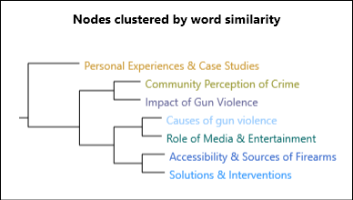

**APPENDIX 3: Screenshot of Nvivo Coding**

